

***INSTITUTE OF INFORMATION TECHNOLOGY***

***JAHANGIRNAGAR UNIVERSITY***

**Number of Assignment :** 01

**Submission Date :** 22/06/2021

**Course Tittle :** Discrete Mathematics

**Course Code :** ICT - 1207

**Submitted To Submitted By**

Dr. M. Mesbahuddin Sarker Md. Shakil Hossain

Professor Roll – 2023

IIT – JU 1st  year 2nd Semester

IIT – JU

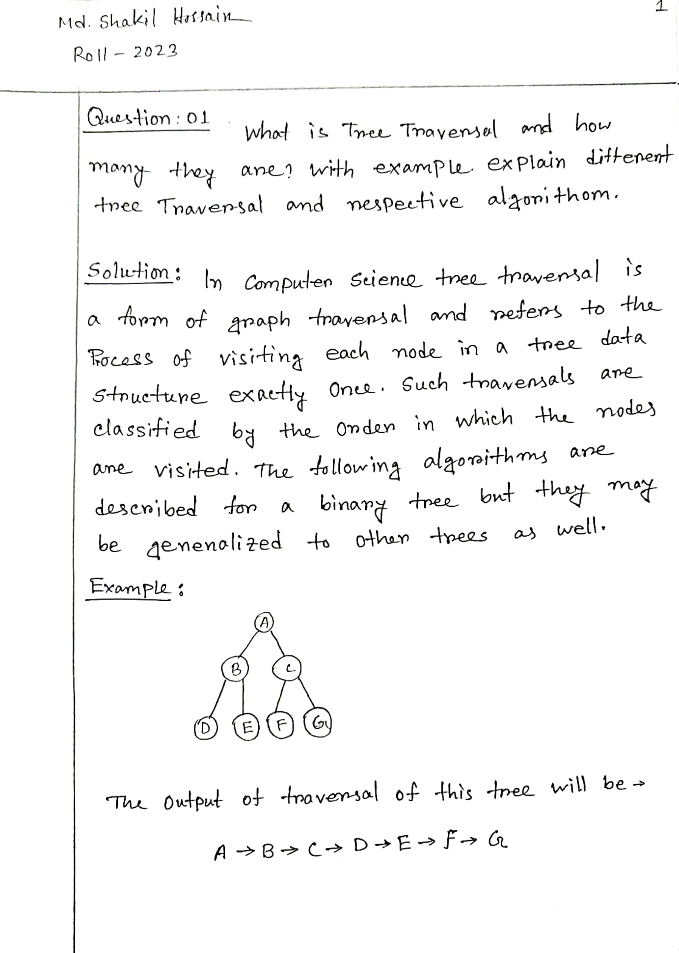

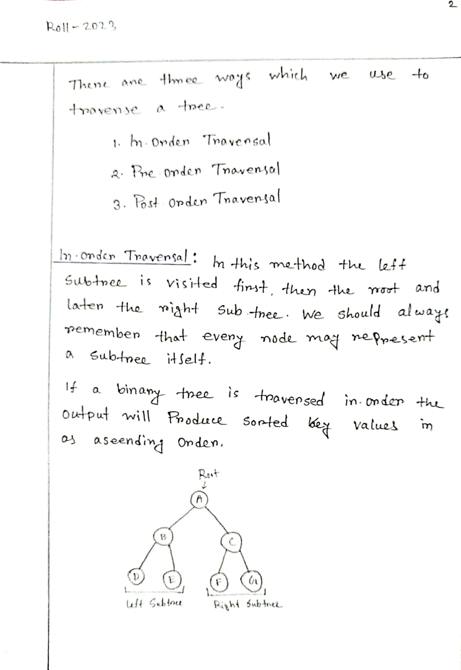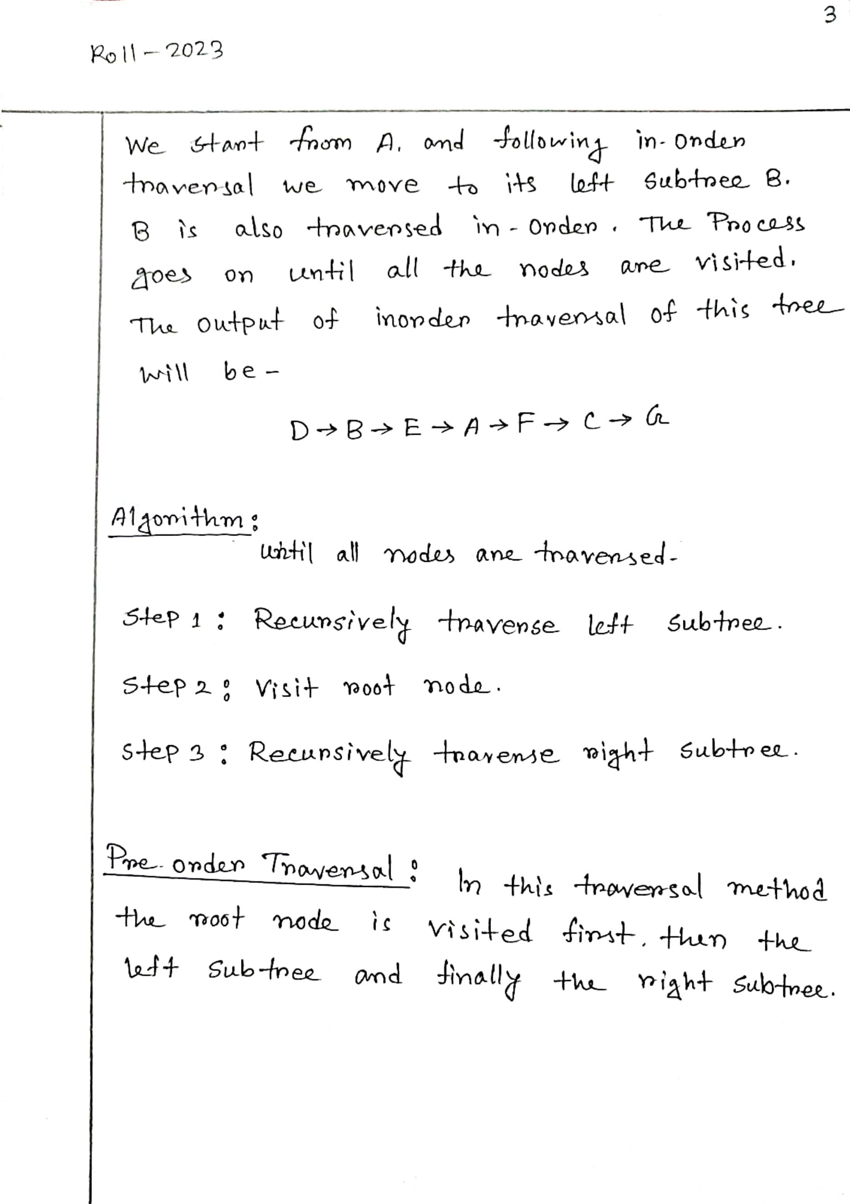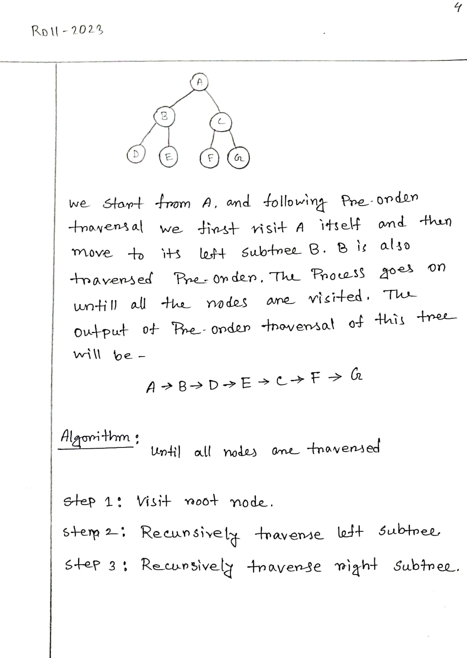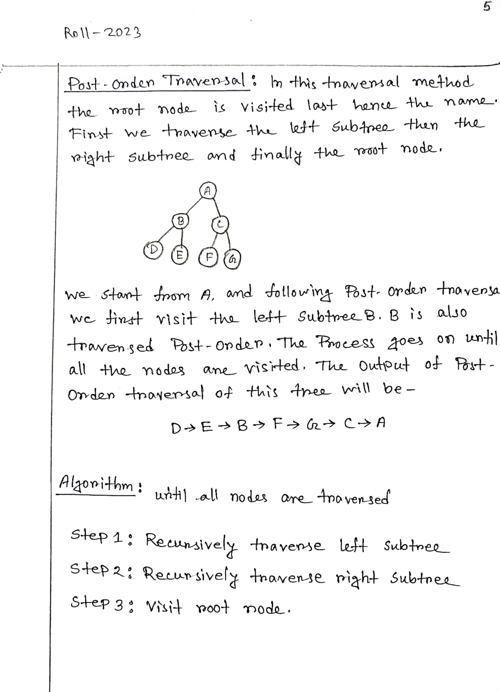

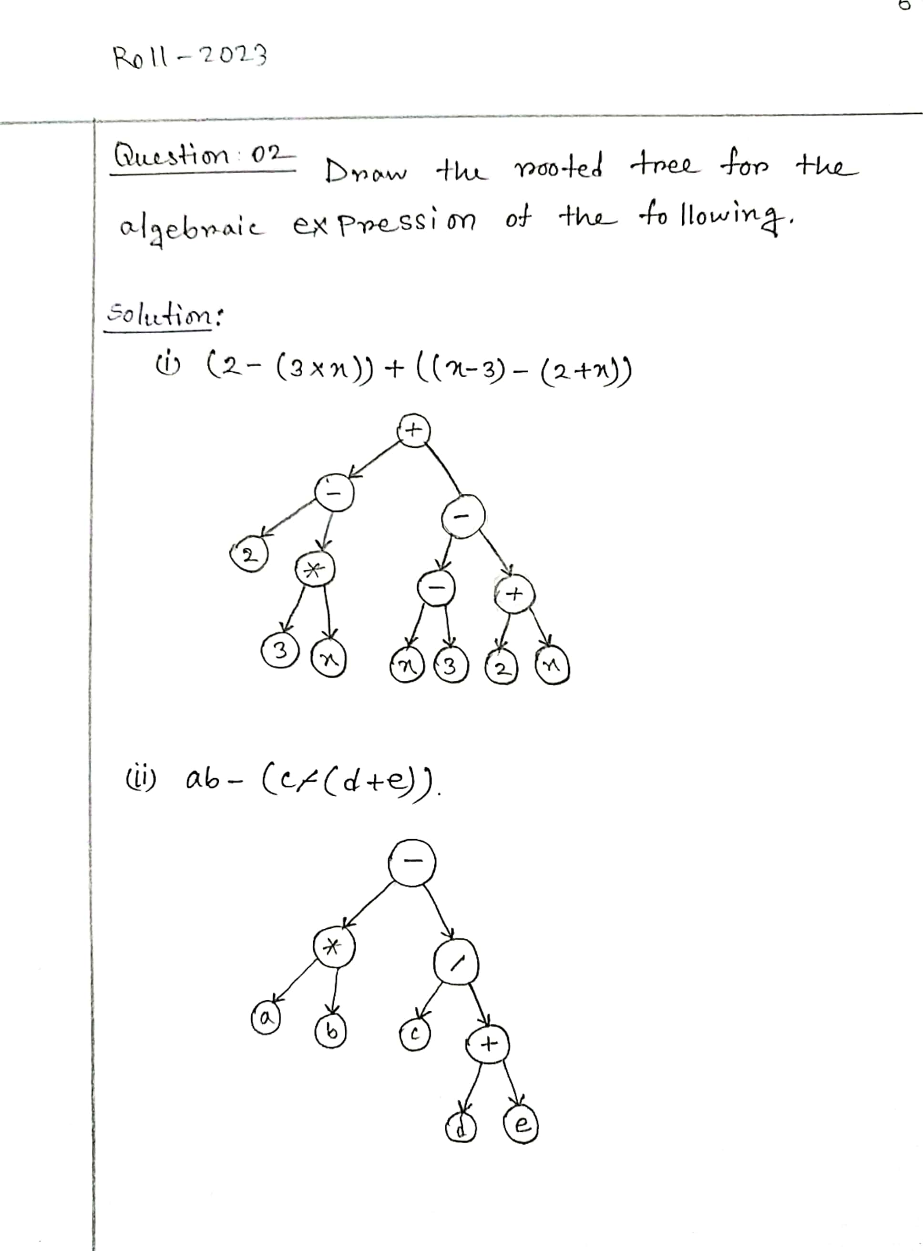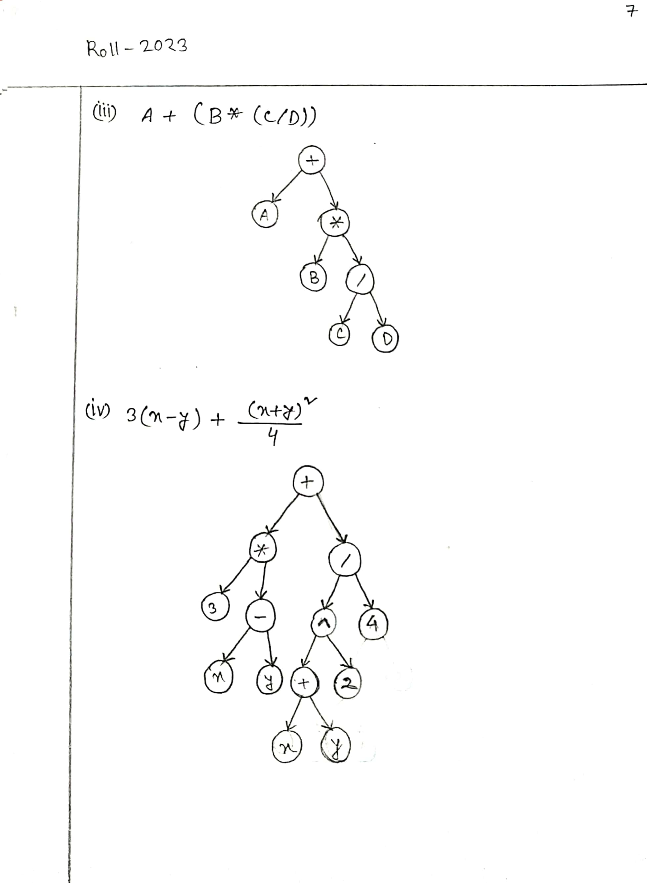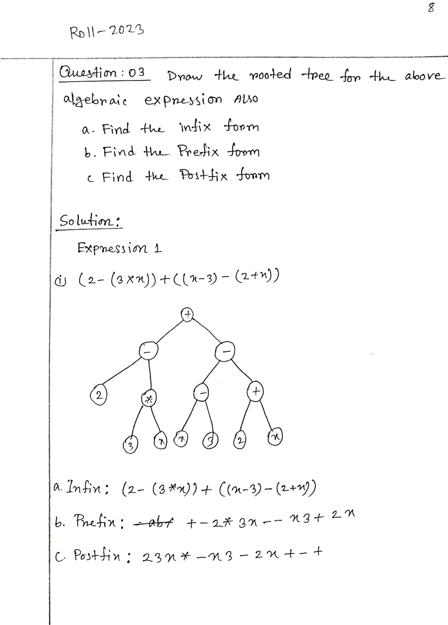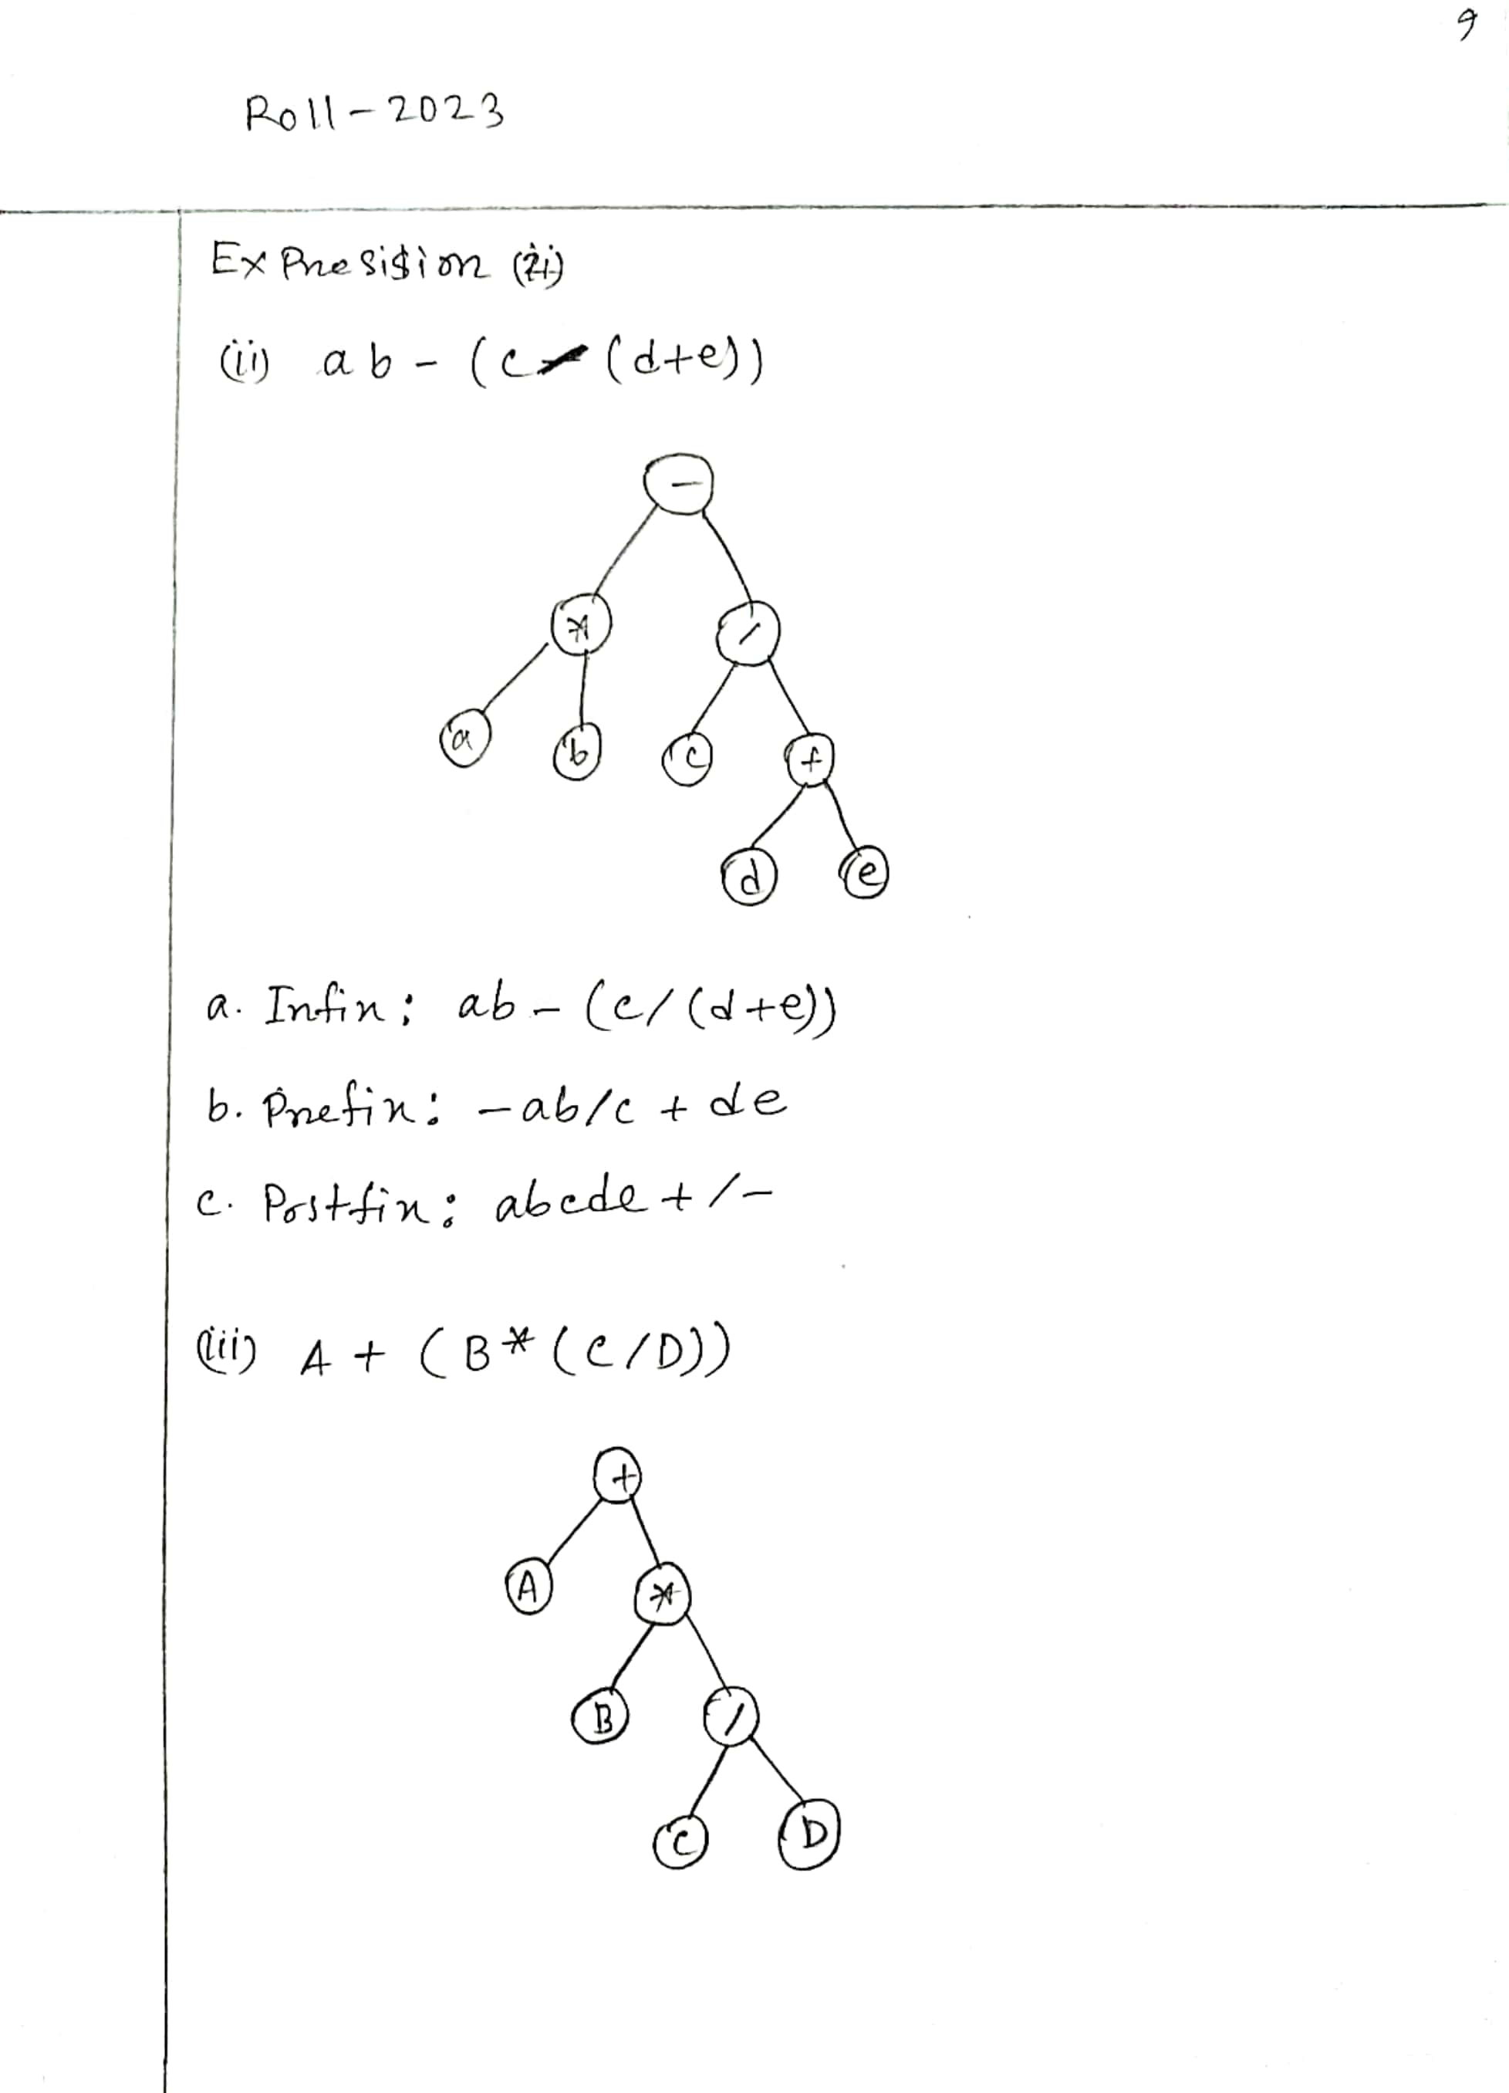

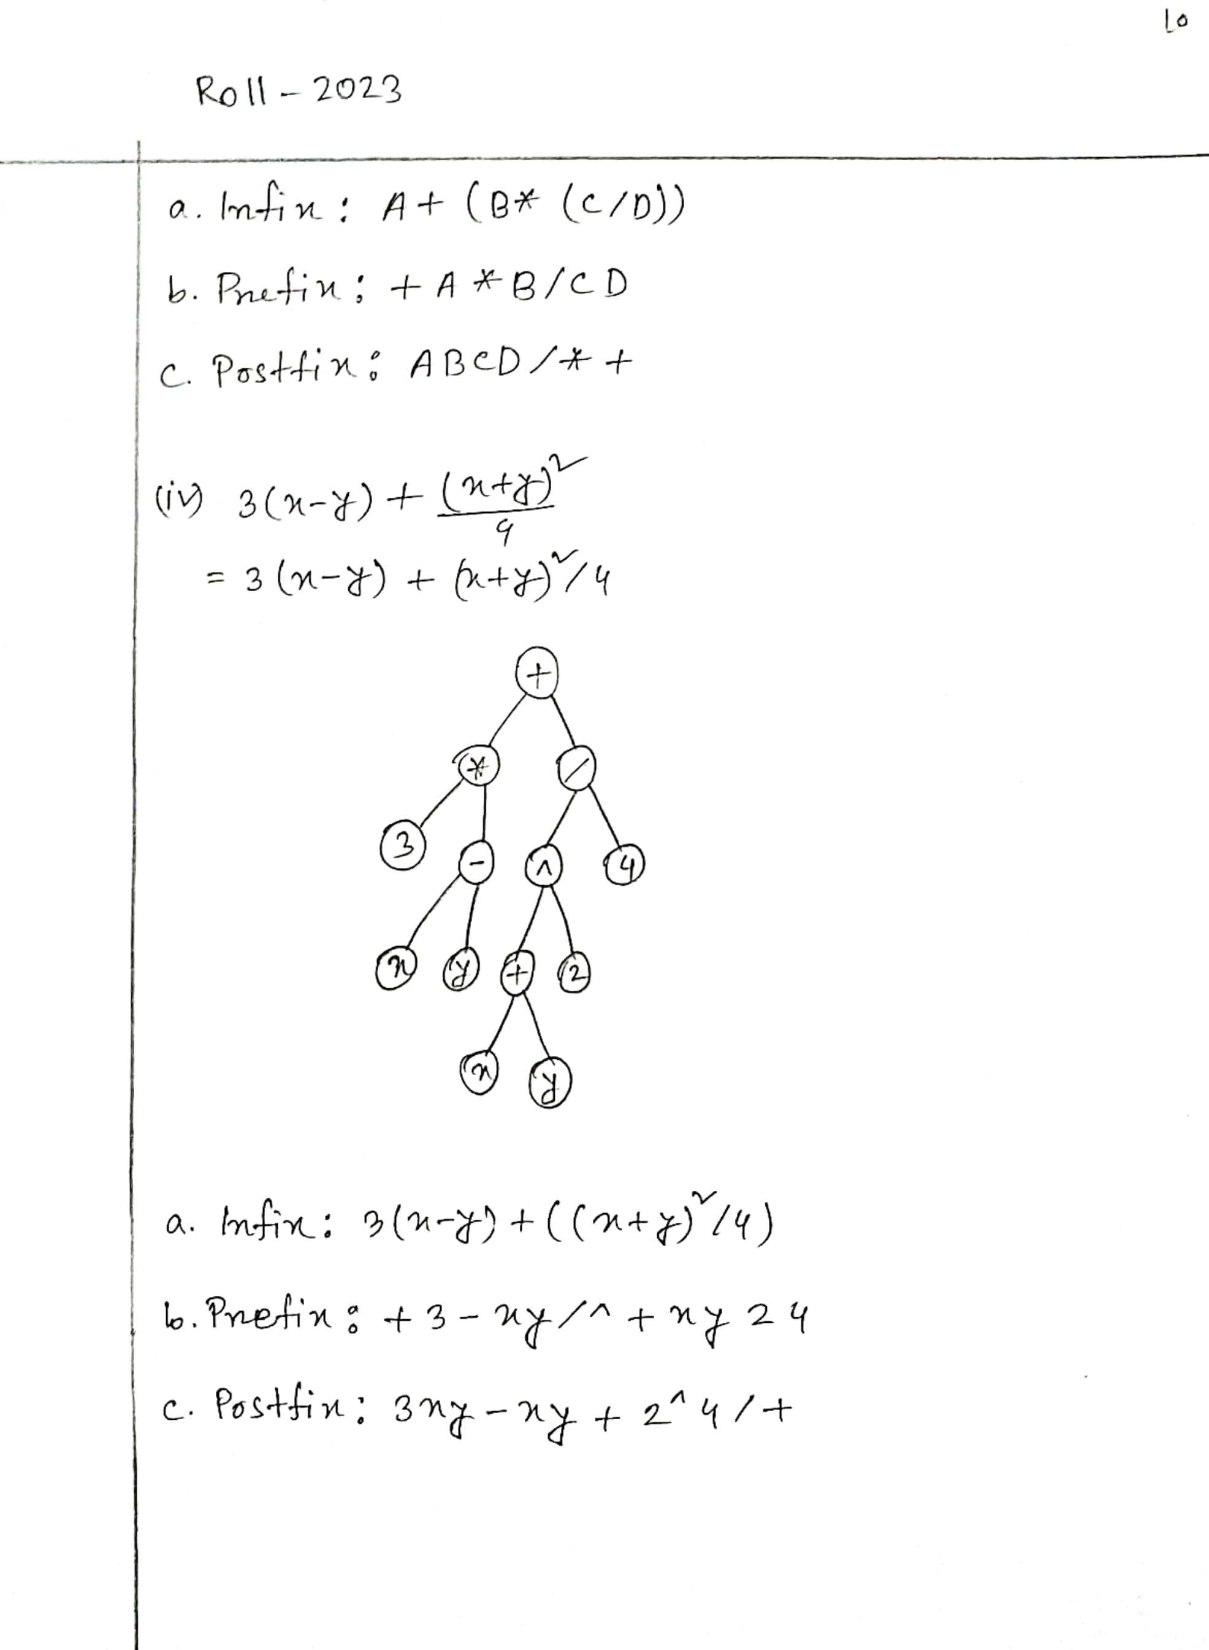

**THE END**